**Assignment 1:**

1.

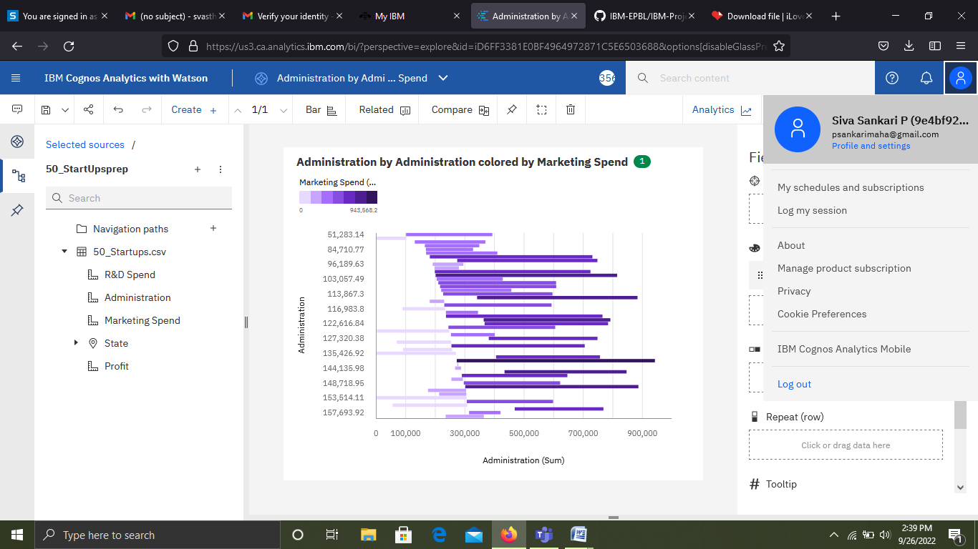

<https://us3.ca.analytics.ibm.com/bi/?perspective=explore&pathRef=.my_folders%2FAdministration%2Bby%2BAdministration%2Bcolored%2Bby%2BMarketing%2BSpend&subView=model00000183790e4fb1_00000000>

2. 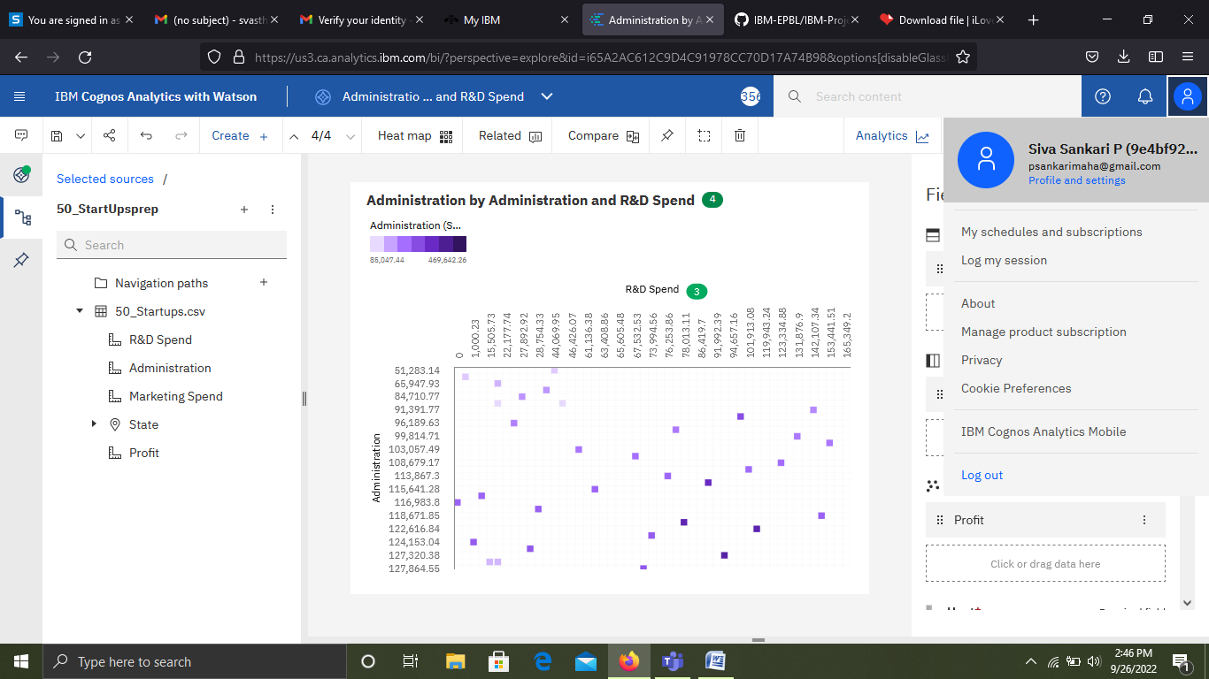

<https://us3.ca.analytics.ibm.com/bi/?perspective=explore&pathRef=.my_folders%2FAdministration%2Bby%2BAdministration%2Band%2BR%2526D%2BSpend&subView=model000001837910fba3_00000004>

3.

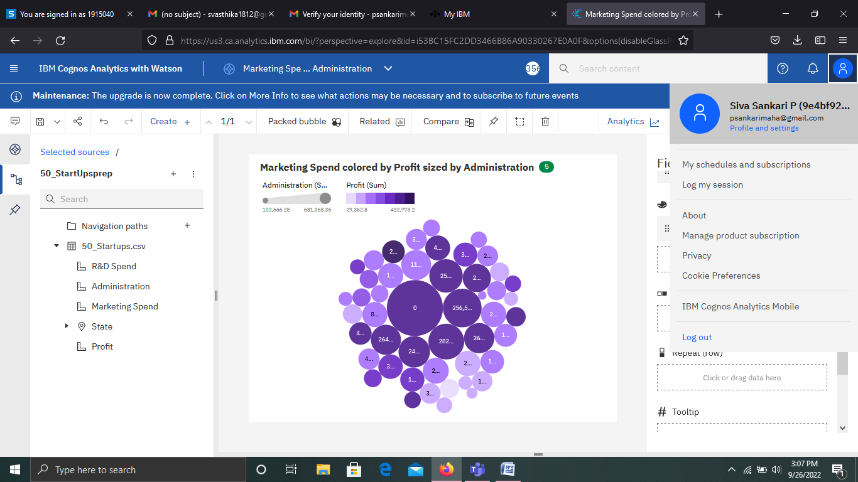

<https://us3.ca.analytics.ibm.com/bi/?perspective=explore&pathRef=.my_folders%2FMarketing%2BSpend%2Bcolored%2Bby%2BProfit%2Bsized%2Bby%2BAdministration&subView=model00000183792787d1_00000000>

4.

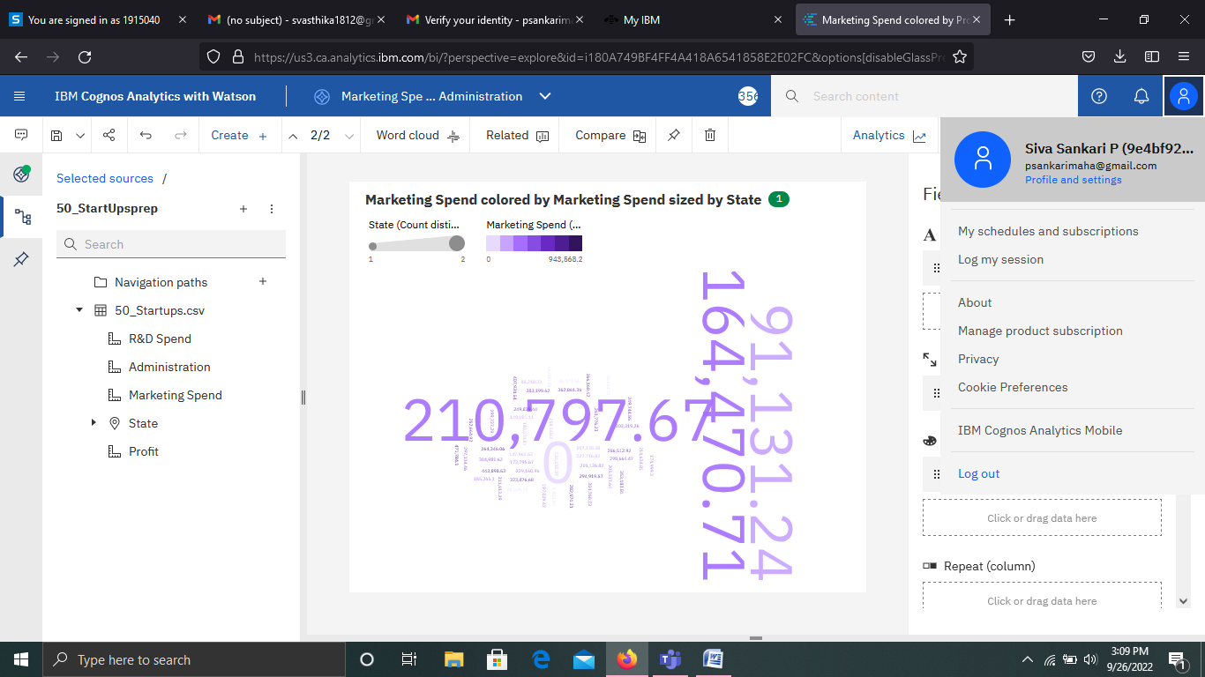

<https://us3.ca.analytics.ibm.com/bi/?perspective=explore&pathRef=.my_folders%2FMarketing%2BSpend%2Bcolored%2Bby%2BProfit%2Bsized%2Bby%2BAdministration&subView=model000001837928e9d4_00000000>

5.

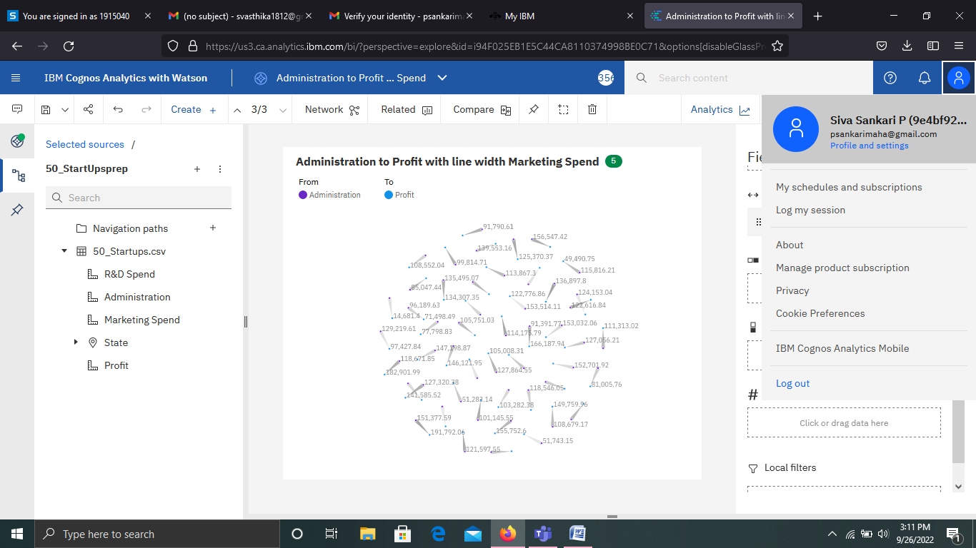

<https://us3.ca.analytics.ibm.com/bi/?perspective=explore&pathRef=.my_folders%2FAdministration%2Bto%2BProfit%2Bwith%2Bline%2Bwidth%2BMarketing%2BSpend&subView=model00000183792b9000_00000000>

6.

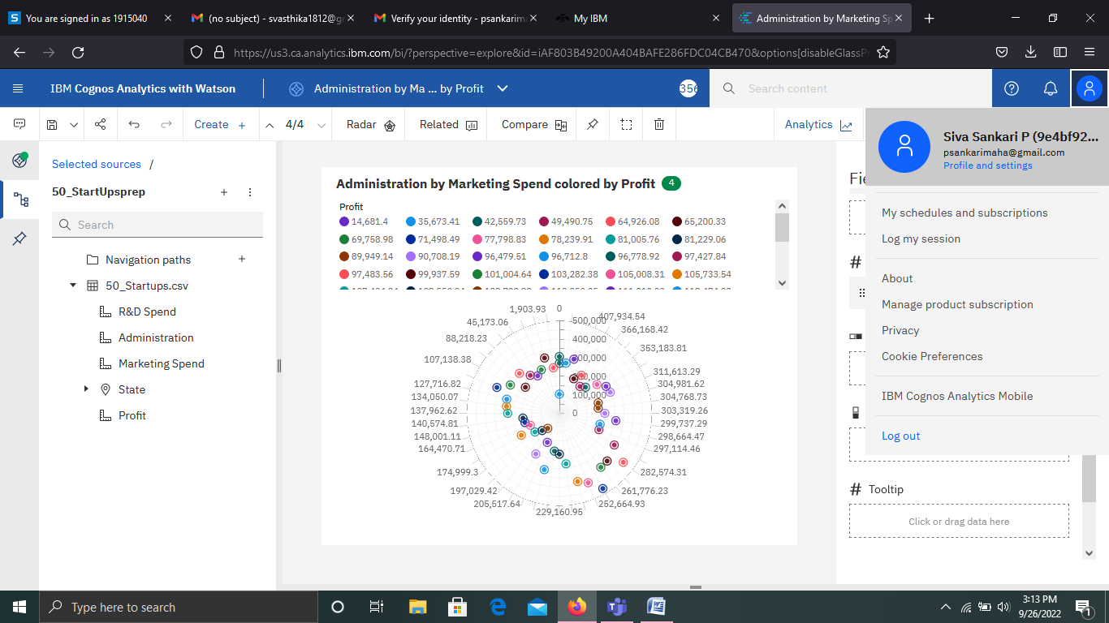

<https://us3.ca.analytics.ibm.com/bi/?perspective=explore&pathRef=.my_folders%2FAdministration%2Bby%2BMarketing%2BSpend%2Bcolored%2Bby%2BProfit&subView=model00000183792d167d_00000000>

7.

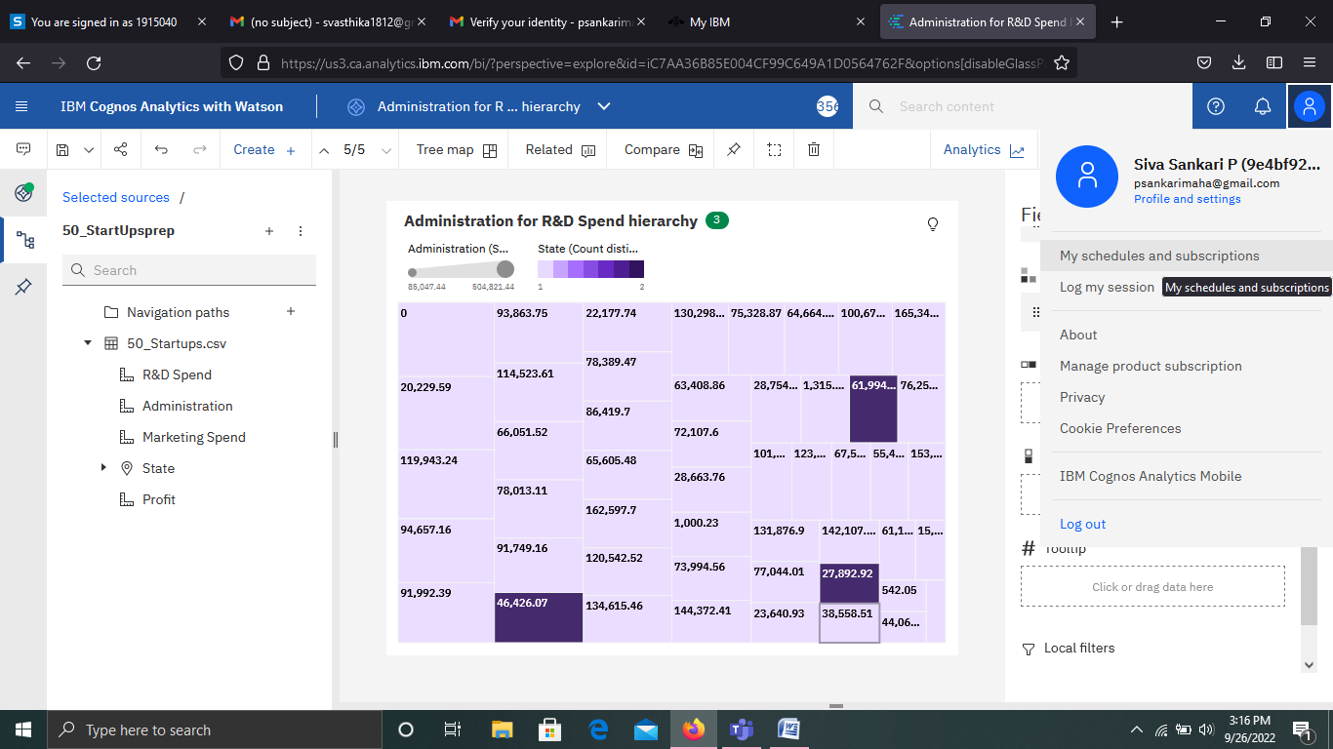

<https://us3.ca.analytics.ibm.com/bi/?perspective=explore&pathRef=.my_folders%2FAdministration%2Bfor%2BR%2526D%2BSpend%2Bhierarchy&subView=model00000183792f56b3_00000000>

8.

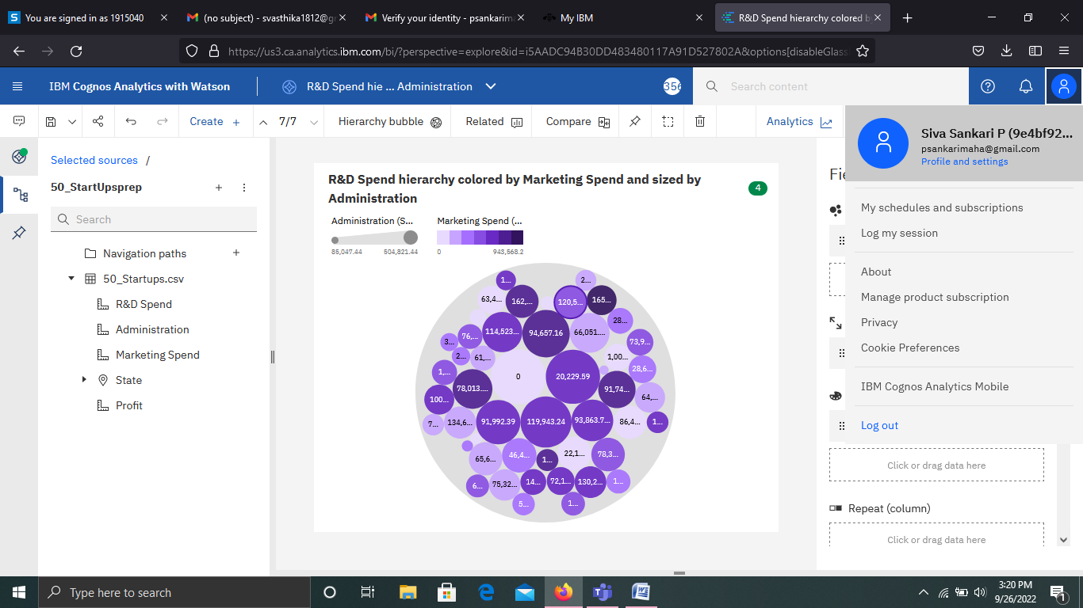

<https://us3.ca.analytics.ibm.com/bi/?perspective=explore&pathRef=.my_folders%2FR%2526D%2BSpend%2Bhierarchy%2Bcolored%2Bby%2BMarketing%2BSpend%2Band%2Bsized%2Bby%2BAdministration&subView=model000001837931ff94_00000000>

9.

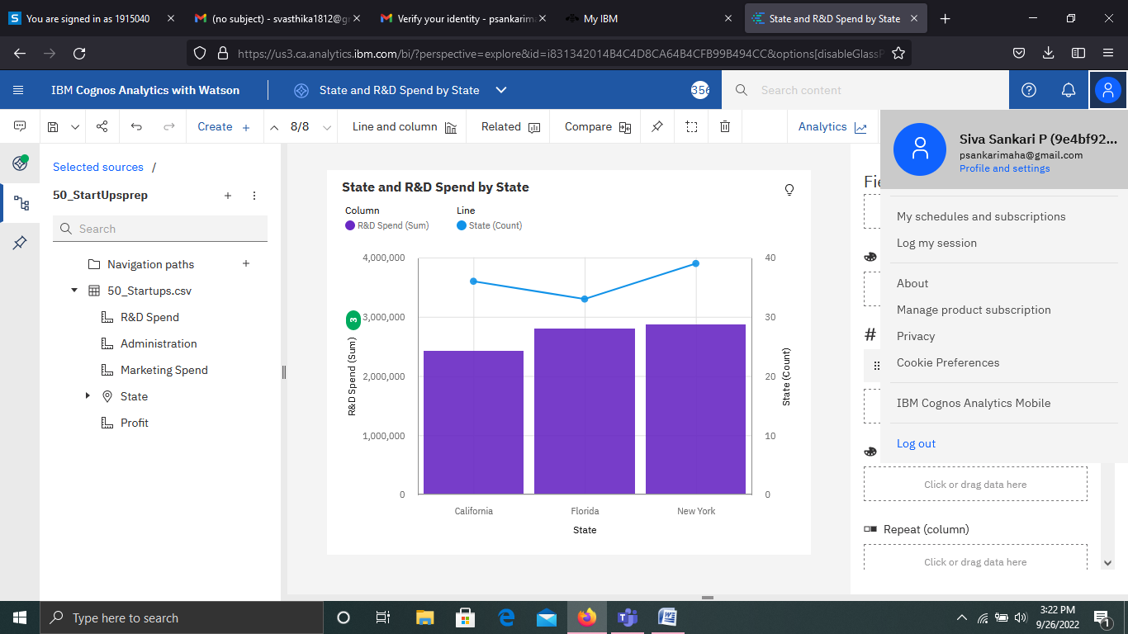

<https://us3.ca.analytics.ibm.com/bi/?perspective=explore&pathRef=.my_folders%2FState%2Band%2BR%2526D%2BSpend%2Bby%2BState&subView=model000001837935bf7d_00000003>

10.

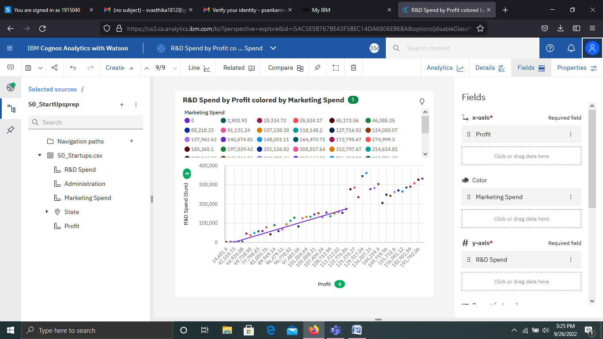

<https://us3.ca.analytics.ibm.com/bi/?perspective=explore&pathRef=.my_folders%2FR%2526D%2BSpend%2Bby%2BProfit%2Bcolored%2Bby%2BMarketing%2BSpend&subView=model0000018379379a47_00000000>

11.

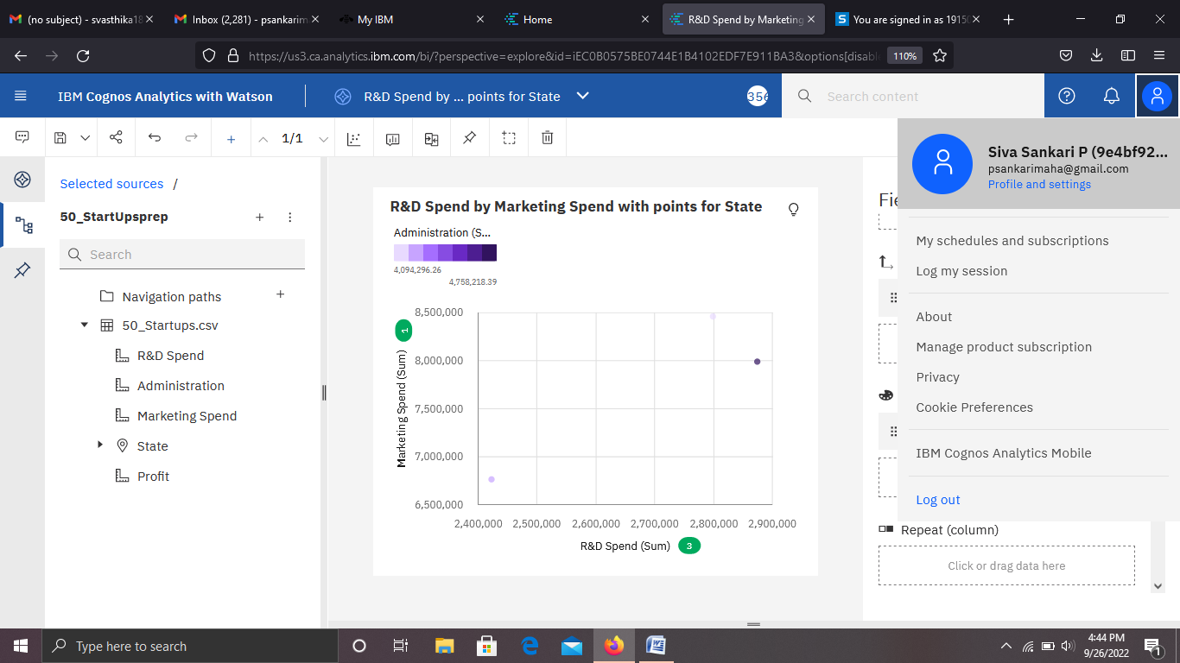

<https://us3.ca.analytics.ibm.com/bi/?perspective=explore&pathRef=.my_folders%2FR%2526D%2BSpend%2Bby%2BMarketing%2BSpend%2Bwith%2Bpoints%2Bfor%2BState&subView=model00000183797ff2fb_00000000>

12.

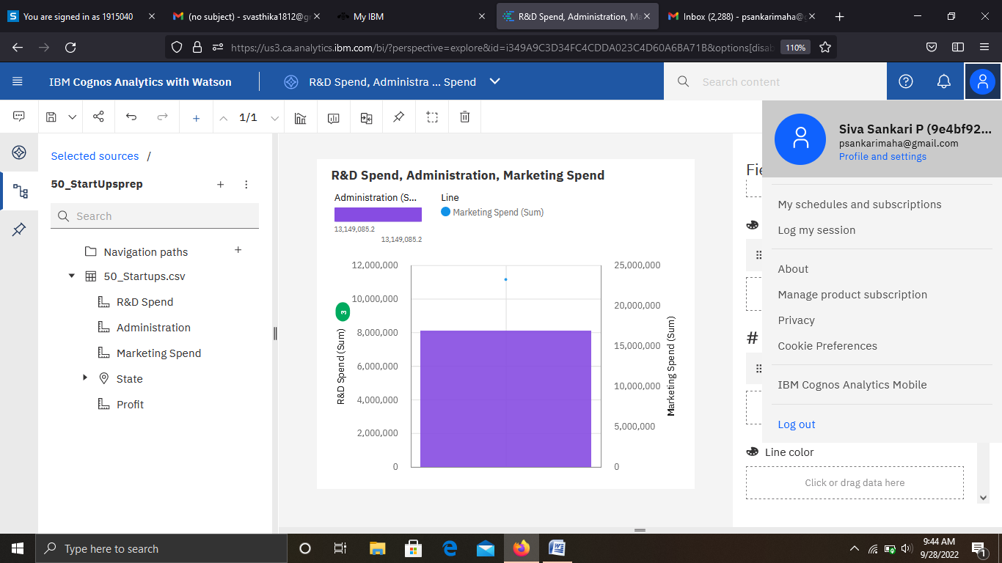

<https://us3.ca.analytics.ibm.com/bi/?perspective=explore&pathRef=.my_folders%2FR%2526D%2BSpend%252C%2BAdministration%252C%2BMarketing%2BSpend&subView=model00000183824c6ebe_00000000>

13.

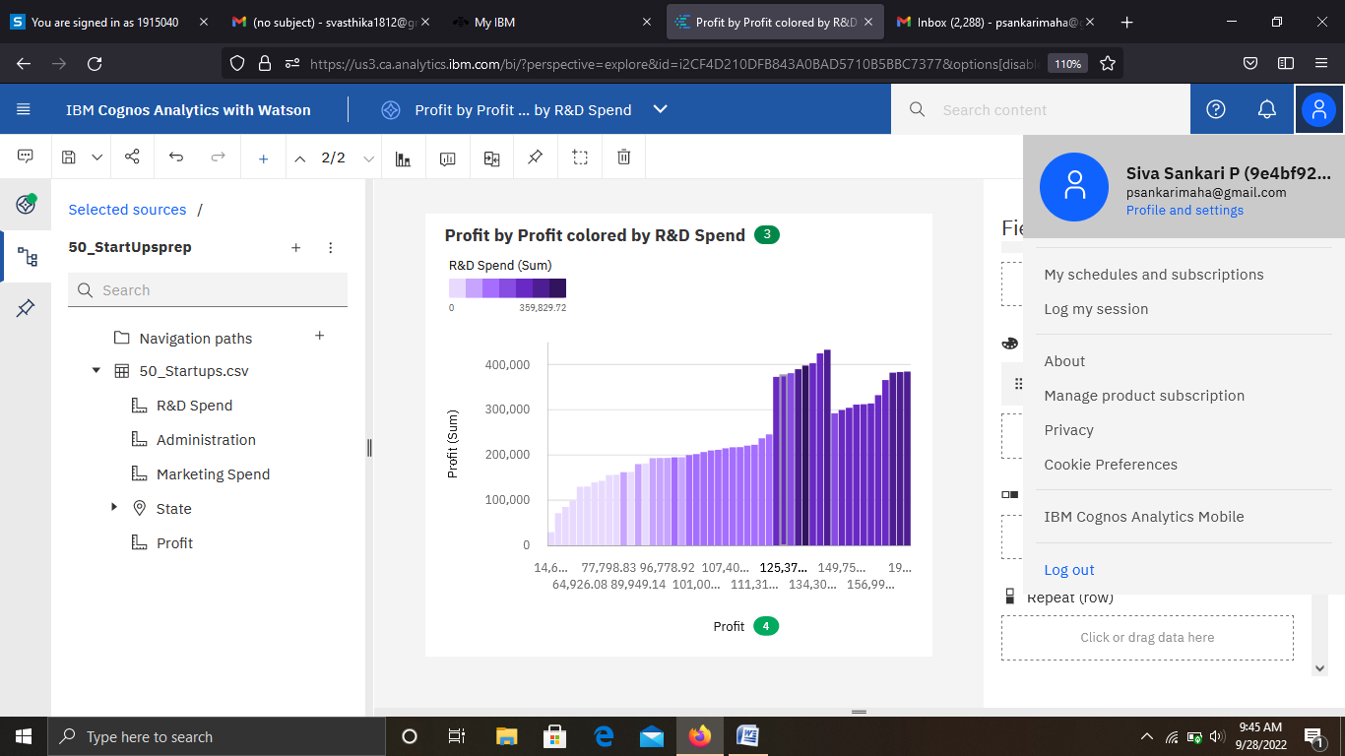

<https://us3.ca.analytics.ibm.com/bi/?perspective=explore&pathRef=.my_folders%2FProfit%2Bby%2BProfit%2Bcolored%2Bby%2BR%2526D%2BSpend&subView=model00000183824e0f37_00000000>

14.

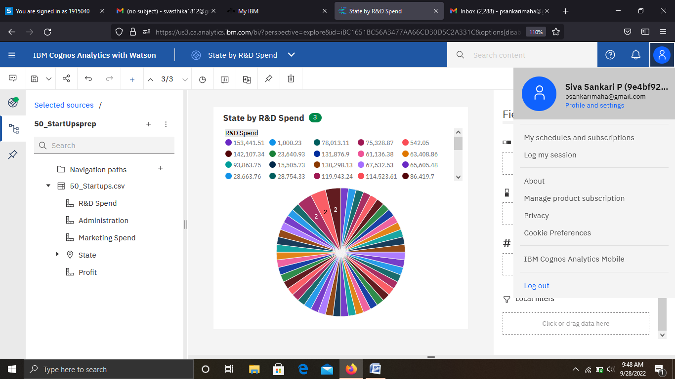

<https://us3.ca.analytics.ibm.com/bi/?perspective=explore&pathRef=.my_folders%2FState%2Bby%2BR%2526D%2BSpend&subView=model000001838250bc57_00000000>

15.

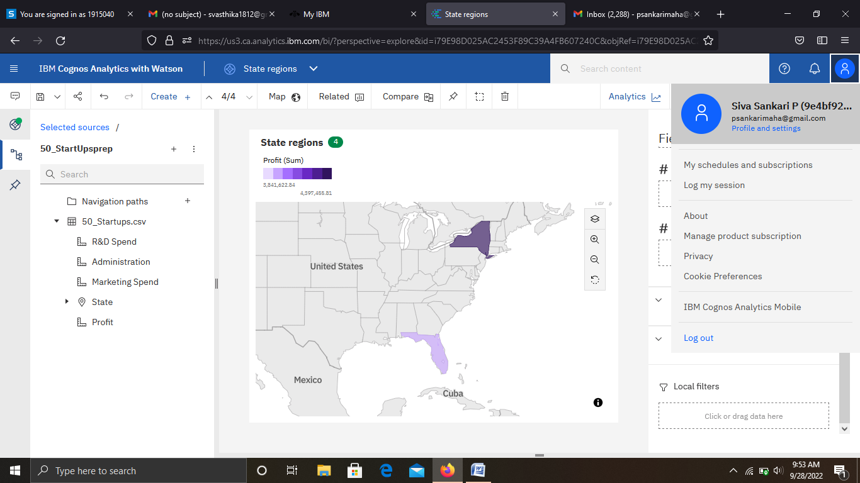

https://us3.ca.analytics.ibm.com/bi/?perspective=explore&pathRef=.my_folders%2FState%2Bregions&subView=model0000018382531283_00000000